Figures:

Figure 1. No Missing Values excerpt

Figure 2. Scatter Plot of Water Vs FLY ASH with strength as an indicator

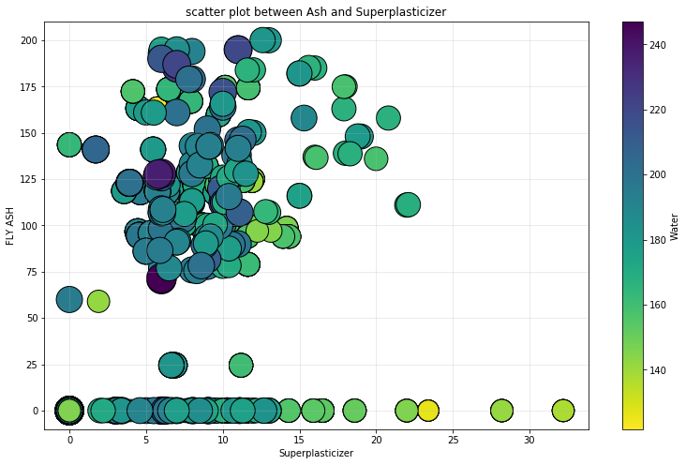

Figure 3. Scatter Plot of Superplasticizer Vs FLY ASH with Water as an indicator

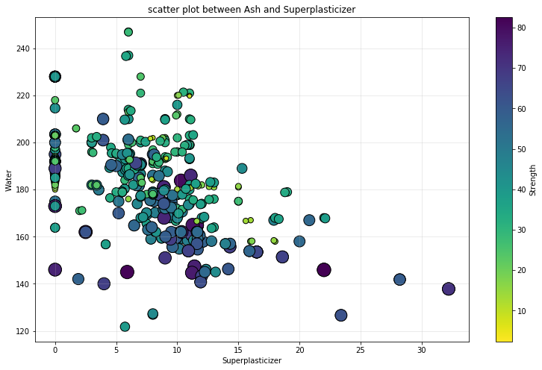

Figure 4. Scatter Plot of Water Vs Superplasticizer with Strength as an indicator

Figure 5. Linear Regression and Random Forest without cross validation R2 scores

Figure 6. PCA implementation done with 4 PC’s

Figure 7. OLS implementation results with a timestamp

Figure 8. Collinearity of the dataset

Figure 9. Linear Regression of the dataset with training and testing scores

Figure 10. Support Vector Machine and PLS Regression implementation

Figure 11. All algorithm results summarized

Figure 12. Linear prediction in bar chart form